Retail Company Data Analysis project

Problem Statement:
A leading retails company wants to better understand its customer’s shopping behavior to improver sales, customer satisfaction, and long- term loyalty. The management team has noticed changes in purchasing patterns across demographics, product categories and sales channels. They are particularly interested in uncovering which factors, such as discounts, reviews, seasons or payment preferences, drive consumer decisions and repeat purchases.
You are tasked with analyzing the company’s consumer behavior dataset to answer the following overarching business questions:
“How can the company leverage consumer shopping data to identify trends, improve customer engagement, and optimize marketing and product strategies?”

Deliverables:
- Data Preparations and Modeling (Python): Clean and transform the raw dataset for analysis.
- Data Analysis (SQL): Organize the data into a structured format, simulate business transactions, and run queries to extract insights on customer segments, loyalty and purchase drivers.
- Visualization and Insights (Power Bi): Build an interactive dashboard that highlights key patterns and trends, enabling stakeholders to make data- driven decisions.
- Report and Presentations: Write a clear project report summarizing you key findings and business recommendations. Prepare a presentation that visually communicates insights and actionable recommendations to take holders.
- GitHub Repository: Include all python script, SQL queries, and dashboard files in a well-structured repository.

Data Analysis Project Report: Customer Behavior Insights

1.Project Overview
Project analyzes customer shopping behavior using transactional data from 3,900 purchases across various product categories. The goal is to uncover insights into spending patterns, customer segments, product preferences and subscription behavior to guide strategic business decisions.
2. DataSet Summary
- Row -3900
-Columns:18
-Key Features
- Customer demographics (Age, Gender, Location, Subscription status)
- Purchase details (Item purchased, Category, Purchase Amount, Season, Size, Color)
- Shopping behavior (Discount applied, Promo code used, Previous purchases, Frequency of purchases, Review Rating, Shipping Type)
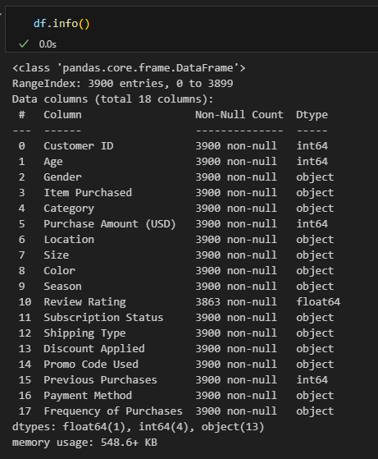

- Tools and Technologies:
- Python: pandas
- SQL: PostgreSQL for data storage and querying
- Power BI: Interactive dashboards for stakeholder review
- Jupyter Notebook: Exploratory analysis and documentation

4.Exploriatory Data Analysis using Python:
Data preparation and cleaning using Python
- Data Loading: Import the dataset using pandas
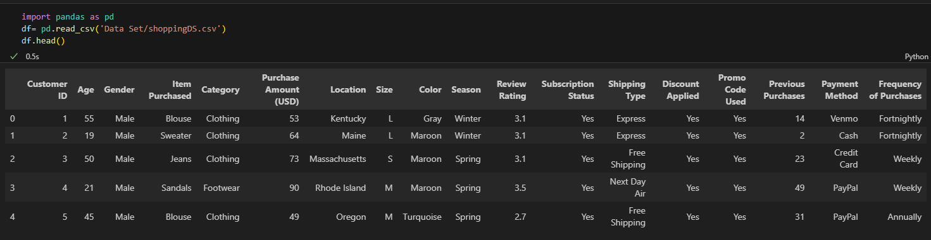

- Initial Exploration: used df.info() to check structure and . describe(include=True) for summary statistics.
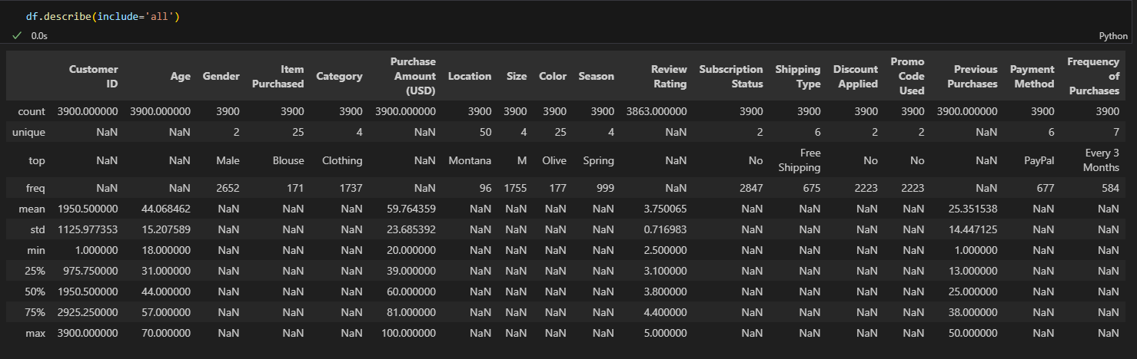
- Missing Data Handling: Checked for null values and imputed missing values in the Review Rating column using the median rating of each product category

- Column Standardization: Renamed columns to “snake case” for better readability and documentation
- Feature Engineering:
- Bucketing the age column using qcut() to create new column
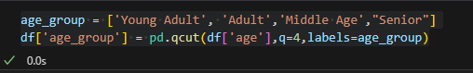
- Created puchases_frequency_days column from purchase data by using the map()
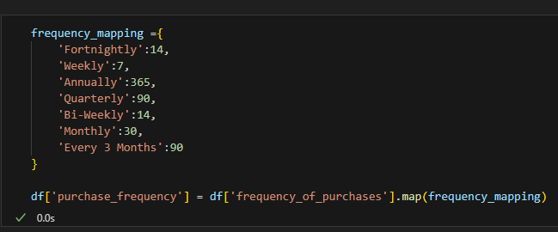

- Data Consistency Check: Verified if discount_applied and promo_code_used were reducndant, dropped promp_code_used.
- Database Integration: Connected Python script to PostgresSQL and loaded the cleaned DataFrame into the database for SQL analysis
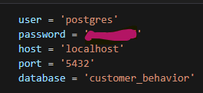
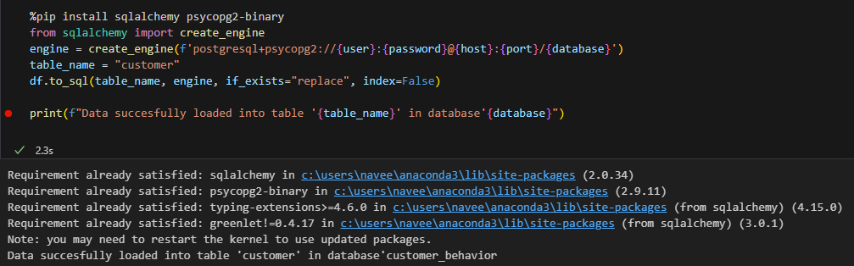

5. Data Analysis using SQL

We prepared and performed structured analysis in PostgreSQL to answer key questions
- What is the total revenue generated by male vs female customers?
select gender, sum(purchase_amount) as revenue
from customer
group by gender
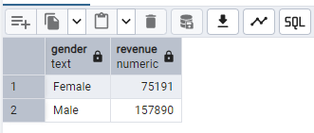
- Which customer used a discount but still spent more than the average purchase amount?
select customer_id, purchase_amount from customer
where customer.purchase_amount > (select avg(purchase_amount) from customer) and discount_applied = 'Yes'
limit 5
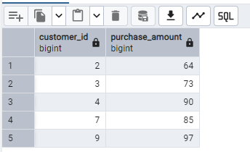
- Which are the top 5 products with the highest average review rating?
select item_purchased,category,ROUND(avg(review_rating::numeric),2) as avg_rating from customer
group by customer.item_purchased, customer.category
order by avg(review_rating) desc
limit 5
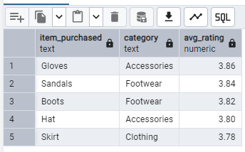
- Compare the average purchase amounts between standard and express shipping
select shipping_type,round(avg(purchase_amount),2) from customer
where shipping_type ='Express' or shipping_type='Standard'
group by shipping_type
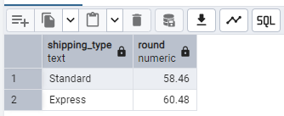
- Do subscribed customers spend more? Compare average spend and total revenue between subscribers and non-subscribers.
select subscription_status,count(customer_id),round(sum(purchase_amount),2) as total_revenu,
round(avg(purchase_amount),2) as average_spend from customer
group by subscription_status
order by total_revenu
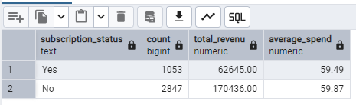
- Which 4 products have the highest percentage of purchases with discounts applied?
select item_purchased, 100*sum(case when discount_applied ='Yes' then 1 else 0 end)/count(*) as discount_rate
from customer
group by item_purchased
order by discount_rate desc
limit 4
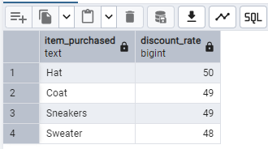
- Segment customers into New, Returning and loyal based on their total number of previous purchases and show the count of each segment.
with customer_type as(
select customer_id,previous_purchases,
CASE
When previous_purchases =1 then 'New'
When previous_purchases Between 2 and 10 then 'Returning'
ELSE 'Loyal'
END as customer_segment
from customer
)
select customer_segment,count(*) as "Number of Customers"
from customer_type
group by customer_segment
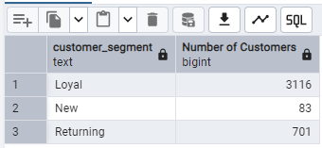

- What is the top 3 most purchased products within each category?
with item_count as (
select category,item_purchased,row_number() over(partition by category order by count(customer_id) desc) as item_rank,count(customer_id) as total_orders
from customer
group by category, item_purchased)

select item_rank,category, item_purchased, total_orders
from item_count
where item_rank<=3
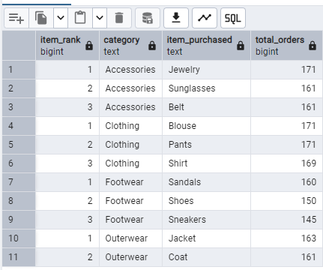
- Are customers who are repeat buyers (more than 5 previous purchases) also likely to subscribe?
select count(customer_id) as cust_sub, subscription_status from customer
where previous_purchases >5
group by subscription_status
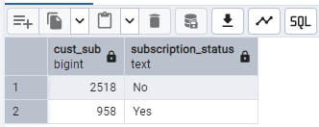
- What is the revenue contribution of each age group?
select age_group,sum(purchase_amount) as revenu from customer
group by age_group
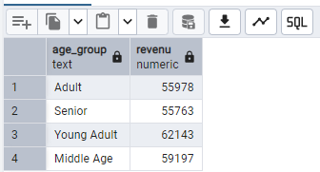
6. PowerBi – Building Dashboard
Connected the PostgresSQL to PowerBi and loaded the data frame to build a Dashboard.
With the PowerBi – Created three measures
- Number of Customer = count('public customer'[customer_id])
- Avg Review Rating = AVERAGE('public customer'[review_rating])
- Avg Purchase Amount = AVERAGE('public customer'[purchase_amount])
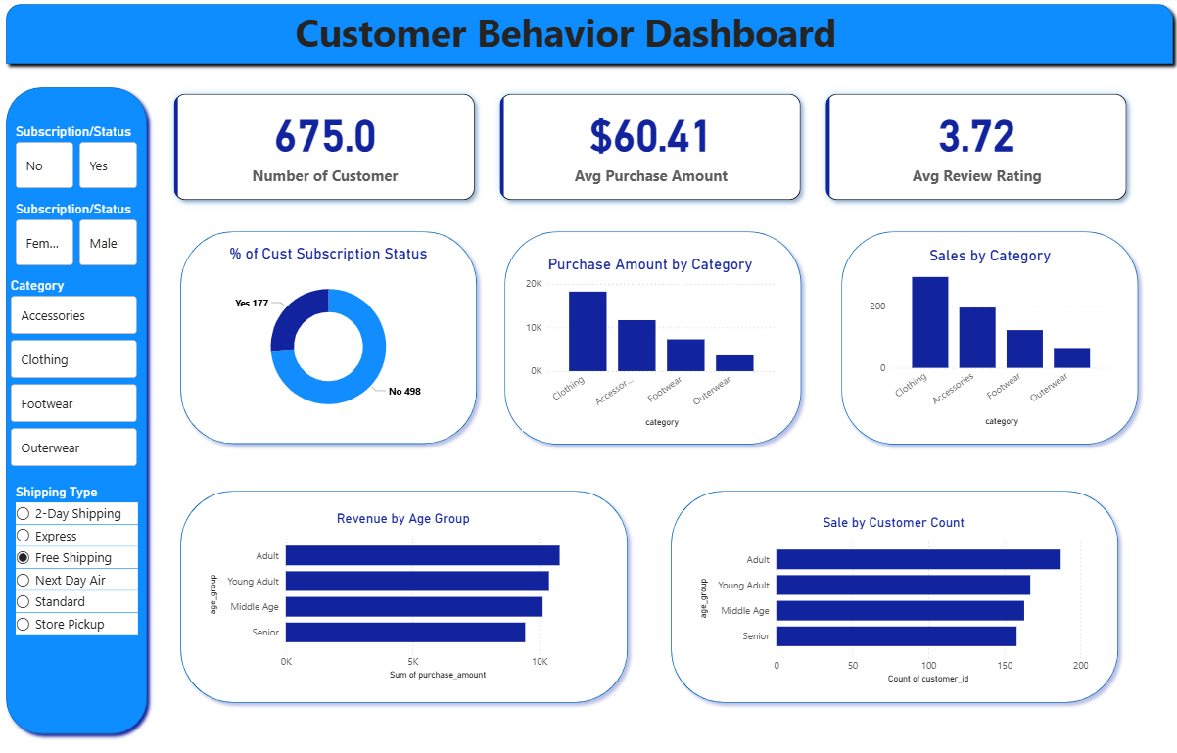

7. Business Recommendations
- Boost Subscriptions – Promote exclusive benefits for subscribers - Finding from SQL query 9
- Customer Loyalty Programs – Reward repeats buyers to move them into the “Loyal” segment
- Product Positioning- Highlight top-rated and best-selling products in campaigns.
- Targeted Marketing- Focus efforts on high-revenue age groups and express-shipping users.

